CSS Properties

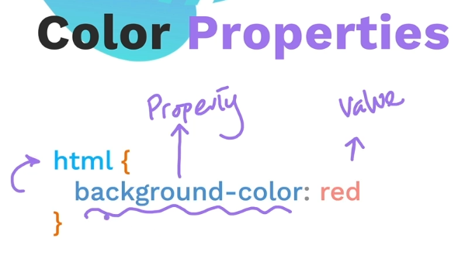

Named colors

<https://developer.mozilla.org/en-US/docs/Web/CSS/named-color>

## [Syntax](https://developer.mozilla.org/en-US/docs/Web/CSS/named-color#syntax)

CSSCopy to Clipboard

color: red;

color: orange;

color: tan;

color: rebeccapurple;

color: transparent;

Value

Named colors consists of standard colors, the transparent and currentcolor keywords.

In addition to these 16 colors, about 150 other colors have a keyword associated to them:

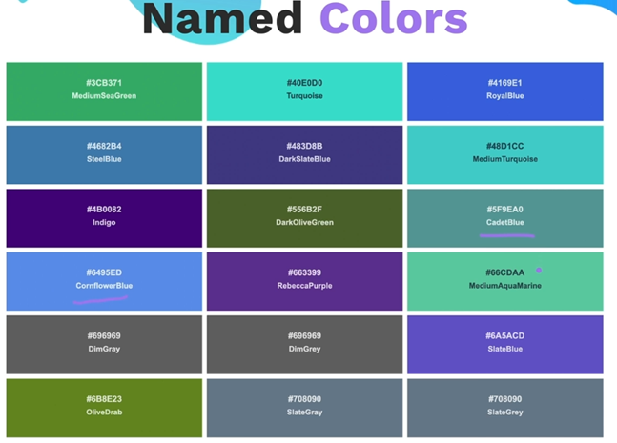

Colorhunt.co

<https://colorhunt.co/>

hex codes for colors

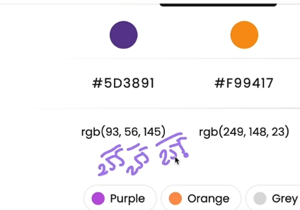

<https://www.csfieldguide.org.nz/en/interactives/rgb-mixer/>

39 Font Properties

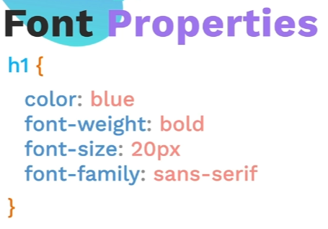

What size is a px ?

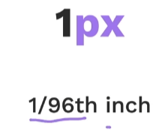 or 0.26 mm

Could also be a point – word uses font sizes of points

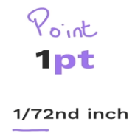

1 em parent or 1 rem root

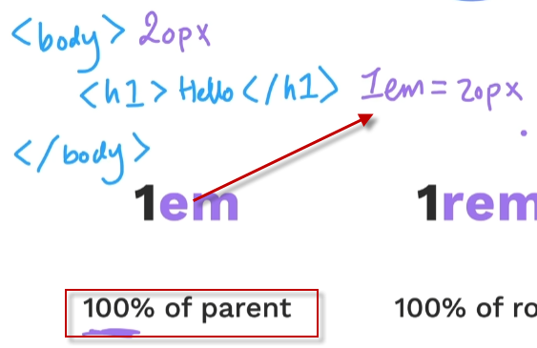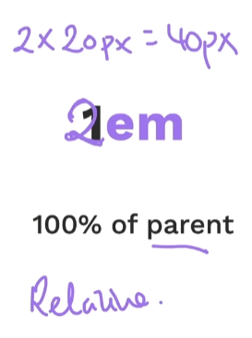

A rem is relative to root – it is more consistent and the recommended unit

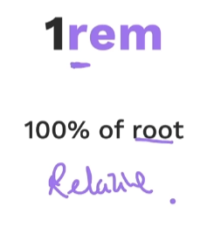 or HTML tag

Font Weight – normal and bold , lighter, bolder, or number

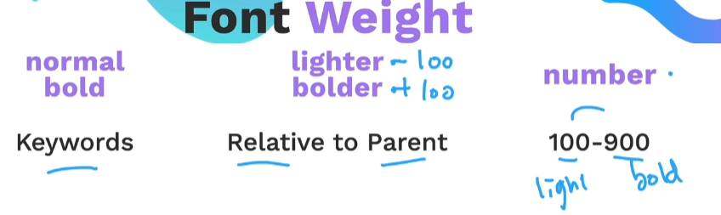

Font Family s

Appearance – Typeface can vary by type of operating system so generic backup passed after a ,

If multi word font need to but the name of the font family in quotes

More on typeface later

Can get many fonts from google.

<https://fonts.google.com/>

Text Align – center, left, right, start, end

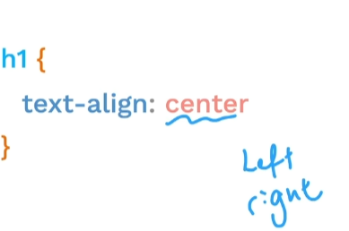

40 inspect css

Chrome browser has dev tools

Cntl shift i or F12

In dev tools to CSS overview – shows info about colors, font, media quersys ectl

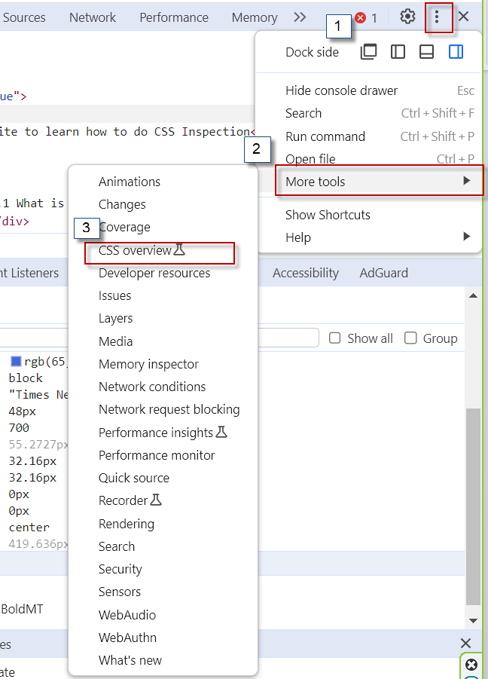

41 CSS Box Model margin padding and border

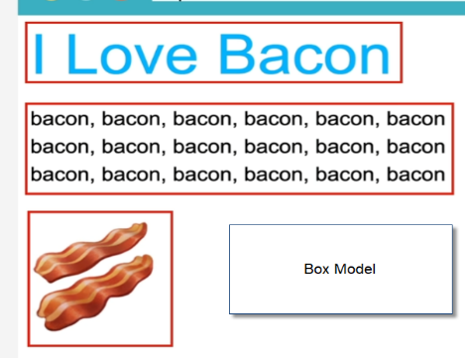

Border 3 values separated by a space

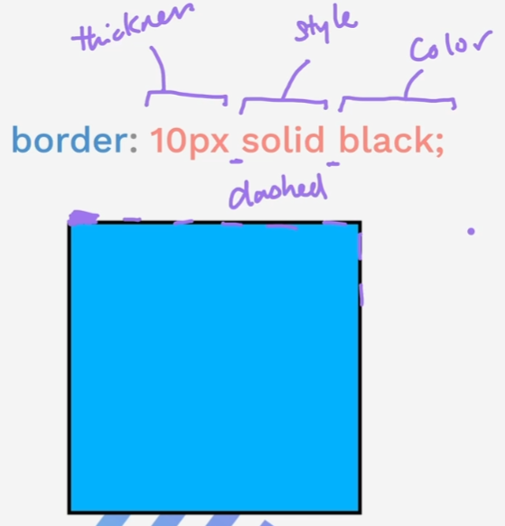

The border does not increase the size of the box ,if it is thicker it becomes so by going out. 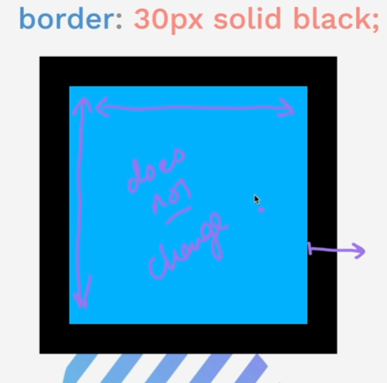

Can also on the next line after creating the border one can define top , right, bottom, let clockwise 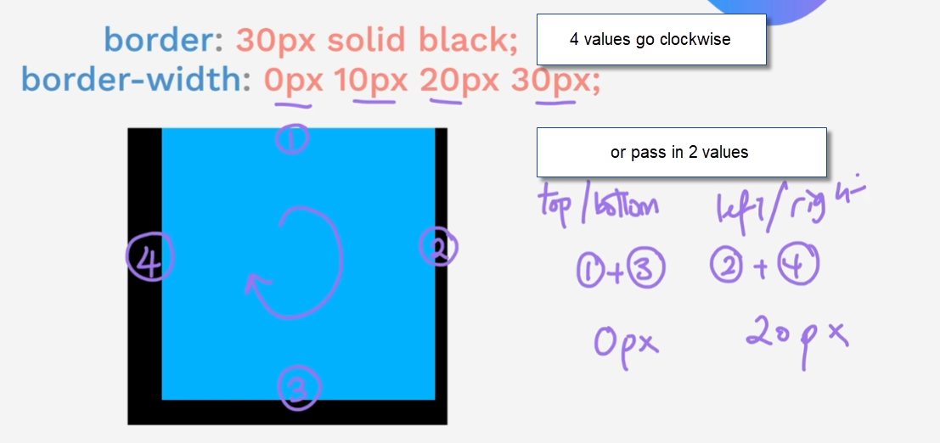

42 Motivational Poster –

Padding – pushes to border out but the box stays the same , puts some space around text and border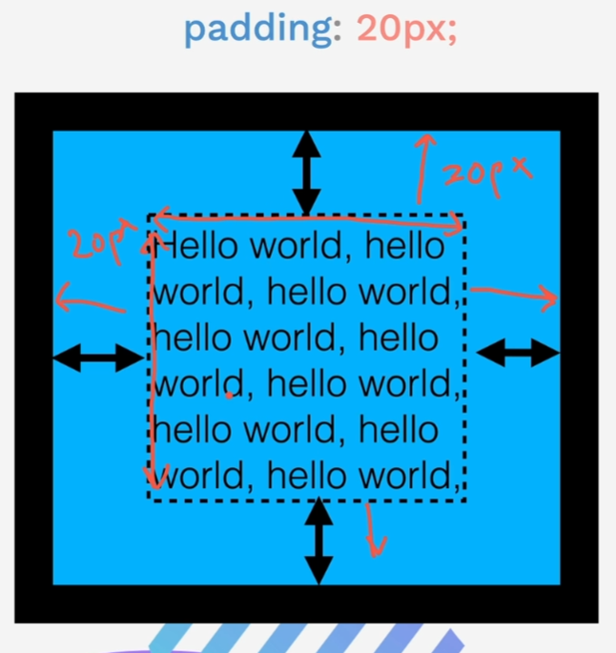

Margin – the part outside of the border

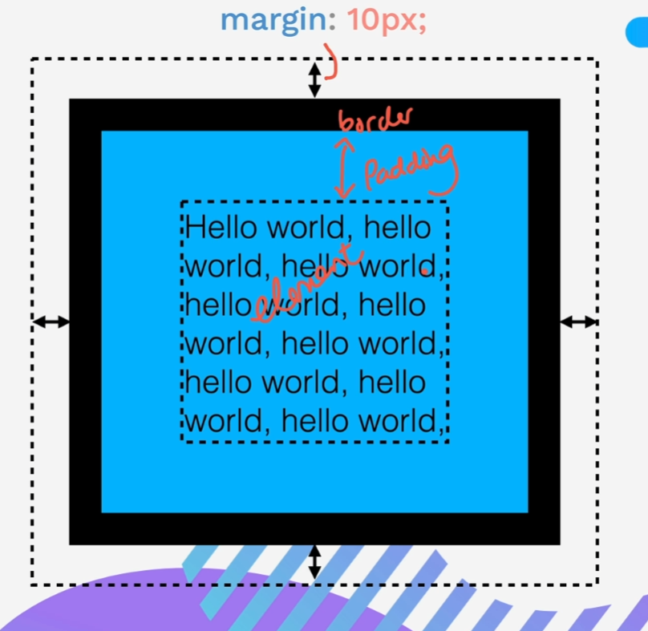

Adds space between elements

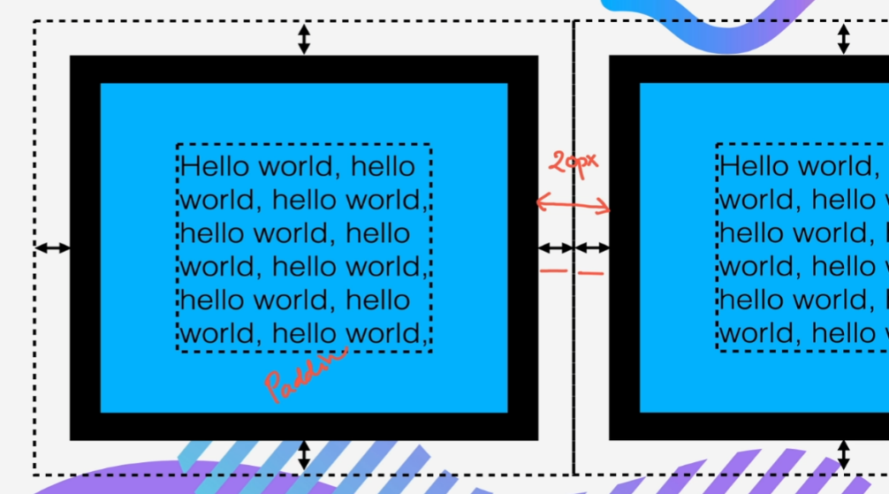

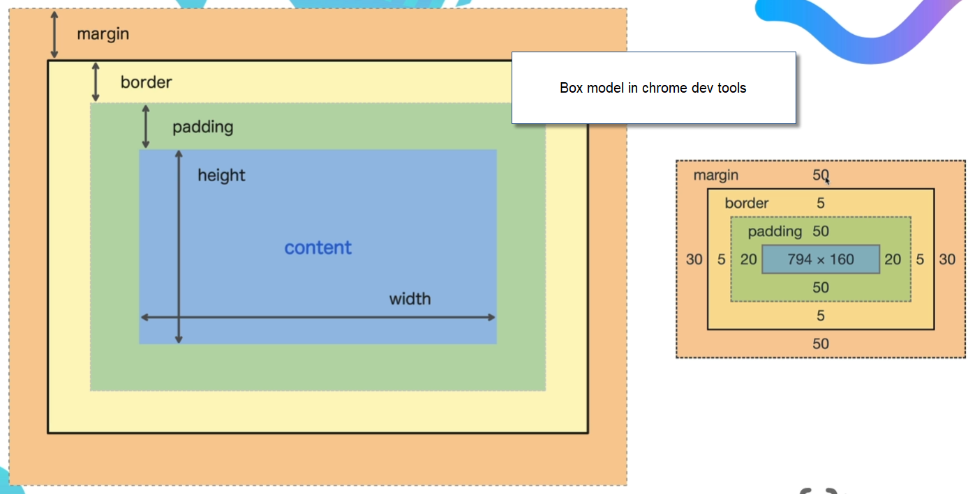

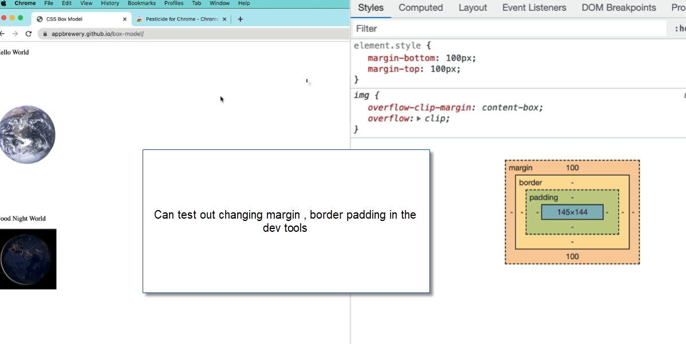

Can group boxes by wrapping in a div or content division element , divs are invisible until content is put into them

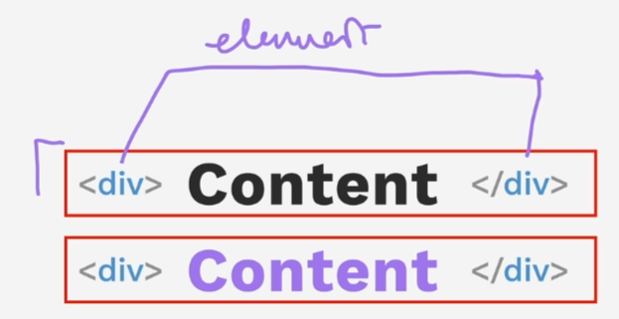

Pesticide chrome extension for debugging is good

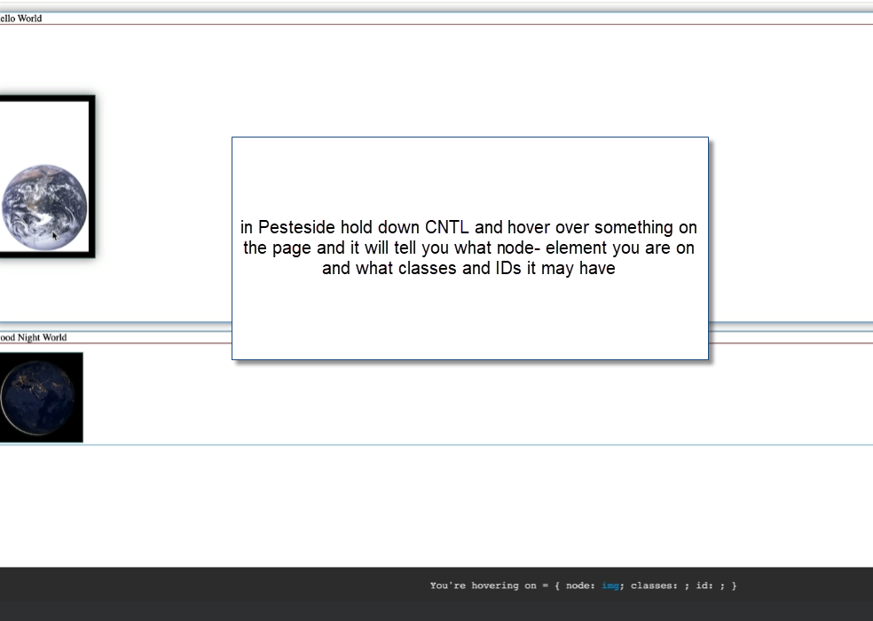

Start here

<https://www.udemy.com/course/the-complete-web-development-bootcamp/learn/lecture/37350454#overview>